Step 3.Connect to the MySQL server using the mysql client program. The mysql program is located in the bin directory of the MySQL installation folder.

C:\Archivos de programa\Mysql\MySQL Server 8.0\bin>
> mysql -u root -p
Enter password: ********Code language: SQL (Structured Query Language) (sql)
You will need to enter the password for the root user account to log in.

Step 4.Use the source command to load data into the MySQL Server:
mysql> source c:\temp\mysqlsampledatabase.sqlCode language: SQL (Structured Query Language) (sql) NO ES NECESARIO ESTE PASO
mysql>source C:\Users\ACER\Desktop\ORACLE\mysqlsampledatabase\mysqlsampledatabase.sql

Step 5. Use the SHOW DATABASES command to list all databases in the current server:
mysql> show databases;Code language: SQL (Structured Query Language) (sql)
The output will look like the following that includes the newly created classicalmodels database:
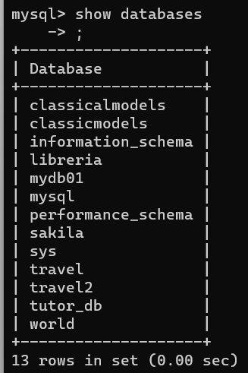
In this tutorial, you have learned step by step how to load the sample database into MySQL server using the mysql tool.

MySQL Sample Database Schema
The MySQL sample database schema consists of the following tables:
- Customers: stores customer’s data.
- Products: stores a list of scale model cars.
- ProductLines: stores a list of product line categories.
- Orders: stores sales orders placed by customers.
- OrderDetails: stores sales order line items for each sales order.
- Payments: stores payments made by customers based on their accounts.
- Employees: stores all employee information as well as the organization structure such as who reports to whom.
- Offices: stores sales office data.
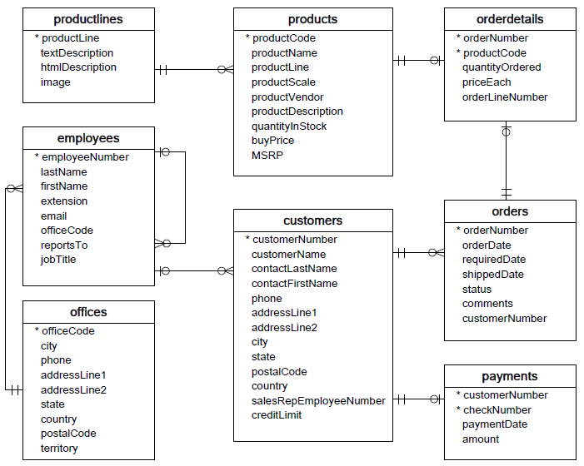
You can download the MySQL sample database ER-diagram in PDF format via the following link.
Download MySQL Sample Database Diagram PDF A4
We recommend that you print the ER diagram out and stick it to your desk to get familiar with the schema while learning MySQL. Have fun learning MySQL!
CHAR GPT
How to use CONSTRAINT in mysql
In MySQL, constraints are used to define rules and restrictions on the data that can be inserted, updated, or deleted in a table. They help maintain data integrity and ensure that the data stored in the database follows certain rules. There are several types of constraints you can use in MySQL, such as primary keys, foreign keys, unique constraints, and check constraints. Here's how you can use each of these constraints:
- Primary Key Constraint: A primary key constraint is used to uniquely identify each row in a table. It ensures that the values in the primary key column(s) are unique and not null.
- Foreign Key Constraint: A foreign key constraint establishes a relationship between two tables, where the values in one table's column(s) must match values in another table's primary key column(s).
- Unique Constraint: A unique constraint ensures that the values in the specified column(s) are unique across all rows in the table.
- Check Constraint: A check constraint specifies a condition that must be satisfied for the data in a column.
- Adding Constraints to Existing Tables: You can add constraints to existing tables using the ALTER TABLE statement.
Primary key constraint
CREATE TABLE students (
student_id INT PRIMARY KEY,
name VARCHAR(50),
age INT
);

Foreign Key Constraint
CREATE TABLE orders (
order_id INT PRIMARY KEY,
customer_id INT,
order_date DATE,
FOREIGN KEY (customer_id) REFERENCES customers(customer_id)
);
Unique constraint
CREATE TABLE employees (
employee_id INT PRIMARY KEY,
email VARCHAR(100) UNIQUE,
first_name VARCHAR(50),
last_name VARCHAR(50)
);
Check constraint
CREATE TABLE products (
product_id INT PRIMARY KEY,
product_name VARCHAR(100),
price DECIMAL(10, 2),
stock_quantity INT,
CHECK (price > 0 AND stock_quantity >= 0)
);
Adding constraint to existing tables
ALTER TABLE orders
ADD FOREIGN KEY (customer_id) REFERENCES customers(customer_id);
Remember that constraints can impact the way you manipulate data, so it's important to design them thoughtfully to ensure they match your data requirements and relationships. If you attempt to insert or update data that violates a constraint, MySQL will raise an error and prevent the operation from completing.

KEY salesRepEmployeeNumber def (salesRepEmployeeNumber), CONSTRAINT customers_ibfk_1 FOREIGN KEY (salesRepEmployeeNumber) REFERENCES employees (employeeNumber) Use KEY and CONSTRAINT in sql mysql?
It looks like you're asking about creating a table in MySQL that includes both a KEY (index) and a FOREIGN KEY constraint. I'll break down your example and explain how to achieve this:
CREATE TABLE customers (
customerNumber INT PRIMARY KEY,
customerName VARCHAR(50),
salesRepEmployeeNumber INT,
-- Creating an index on salesRepEmployeeNumber
KEY salesRepEmployeeNumber_idx (salesRepEmployeeNumber),
-- Creating a foreign key constraint referencing employees table
CONSTRAINT customers_ibfk_1 FOREIGN KEY (salesRepEmployeeNumber) REFERENCES employees (employeeNumber)

It looks like you're asking about creating a table in MySQL that includes both a KEY (index) and a FOREIGN KEY constraint. I'll break down your example and explain how to achieve this:

In this example, you are creating a table named customers. Here's what each part of the statement does:
- customerNumber INT PRIMARY KEY: Defines a primary key column for the customers table.
- customerName VARCHAR(50): Defines a column for customer names.
- salesRepEmployeeNumber INT: Defines a column to store the sales representative's employee number.
- KEY salesRepEmployeeNumber_idx (salesRepEmployeeNumber): This line creates an index (KEY) on the salesRepEmployeeNumber column. Indexes improve the performance of search operations on the indexed column.
- CONSTRAINT customers_ibfk_1 FOREIGN KEY (salesRepEmployeeNumber) REFERENCES employees (employeeNumber): This line creates a foreign key constraint named customers_ibfk_1. It enforces referential integrity by ensuring that the values in the salesRepEmployeeNumber column exist in the employeeNumber column of the employees table.
By including both the index (KEY) and the FOREIGN KEY constraint in the CREATE TABLE statement, you are optimizing the structure of the table for querying while also establishing a relationship between the customers and employees tables.

Whtat it means _ibfk_1 in CONSTRAINT customers_ibfk_1 FOREIGN KEY (salesRepEmployeeNumber) REFERENCES employees (employeeNumber)
The "_ibfk_1" in the constraint name "customers_ibfk_1" is an automatically generated identifier by MySQL. When you create a foreign key constraint without explicitly specifying a name, MySQL generates a name for the constraint by combining the names of the referring table, the referenced table, and a sequence number. This is done to ensure that each constraint has a unique name within the database.
Let's break down the parts of the constraint name "customers_ibfk_1" from your example:
- "customers": This is the name of the table where the foreign key constraint is defined.
- "ibfk": This is a prefix that MySQL uses for automatically generated foreign key constraint names. It stands for "index-based foreign key."
- "1": This is a sequence number assigned to the constraint. If you were to define multiple foreign key constraints within the same table, MySQL would increment this number to ensure uniqueness.
So, in the context of the statement:
CONSTRAINT customers_ibfk_1 FOREIGN KEY (salesRepEmployeeNumber) REFERENCES employees (employeeNumber)

The name "customers_ibfk_1" is assigned to the foreign key constraint that connects the salesRepEmployeeNumber column in the customers table to the employeeNumber column in the employees table. The "_ibfk_1" portion simply distinguishes this constraint from any other foreign key constraints that might be defined in the same table.

What it means KEY KEY officeCode (officeCode) , mysql is foreign kEY?
It seems like there might be a misunderstanding in your statement. Let's clarify the usage of "KEY" and "FOREIGN KEY" in MySQL.
- KEY: In MySQL, the KEY keyword is used to define an index on one or more columns of a table. Indexes are used to improve the performance of queries by allowing the database to quickly locate rows that satisfy certain conditions. An index can be created on a single column or multiple columns.
- CREATE TABLE employees (
- employeeNumber INT PRIMARY KEY,
- firstName VARCHAR(50),
- lastName VARCHAR(50),
- officeCode INT,
- -- Creating an index on the officeCode column
- KEY officeCode_idx (officeCode)
- );

In this example, an index named "officeCode_idx" is created on the officeCode column of the employees table. This index would help speed up queries involving the officeCode column.
- FOREIGN KEY: A FOREIGN KEY is used to establish a relationship between two tables based on the values of certain columns. The FOREIGN KEY constraint ensures that values in a column of one table correspond to values in a column of another table's primary or unique key.
CREATE TABLE employees (
employeeNumber INT PRIMARY KEY,
firstName VARCHAR(50),
lastName VARCHAR(50),
officeCode INT
);

CREATE TABLE offices (
officeCode INT PRIMARY KEY,
officeName VARCHAR(100)
);

-- Creating a foreign key relationship
ALTER TABLE employees
ADD FOREIGN KEY (officeCode) REFERENCES offices(officeCode);

In this example, a foreign key relationship is established between the officeCode column in the employees table and the officeCode column in the offices table. This ensures that the values in the officeCode column of the employees table correspond to valid values in the offices table.
To summarize, "KEY" is used to create indexes, which improve query performance, while "FOREIGN KEY" is used to define relationships between tables to ensure data integrity. They serve different purposes in database design and optimization.
Principio del formulario

